**YEAR 11 IDENTIFICATION OF UNKNOWN PRACTICE TEST**

**MONDAY DAY 21ST August (Period 2)**

**In this test you will be required to identify four unknown substances.**

Each substance is ionic and will be composed of a combination of the cations and anions below:

|  |  |
| --- | --- |
| **Possible cations** | **Possible anions** |
| barium | carbonate |
| chromium(III) | chloride |
| copper(II) | hydroxide |
| iron(II) | iodide |
| lead(II) | nitrate |
| magnesium | phosphate |
| nickel(II) | sulfate |
| potassium |  |
| sodium |
| strontium |

You will be provided with a solid sample of the substance **AND** a solution containing the dissolved salt.

**SIDE BENCHES:**

* Solid samples of each substance
* Metal loop and Bunsen burner *(for flame tests)*
* Watch glasses and hydrochloric acid  *(for carbonate tests)*

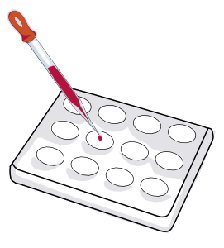**MAIN TABLES:**

* Test tubes containing solutions of each substance
* Spotting tile *(see diagram to right)*
* Labelled solutions of:
  + Sodium chloride
  + Sodium sulfate
  + Sodium carbonate
  + Sodium nitrate
  + Sodium hydroxide
  + Sodium iodide
  + Copper(II) nitrate
  + Lead(II) nitrate
  + Potassium nitrate
  + Silver nitrate
  + Barium chloride
  + Potassium bromide
  + Magnesium sulfate
  + Cobalt(II) chloride

You will have **1 hour** to determine the identity of your salts. You will be sharing equipment with another student, but you will be identifying **different salts** and therefore cannot work together.

**You do not need to use all of the equipment that has been provided. You should decide which tests will be necessary to conduct your experiment.**

**This will be an open book test. You are encouraged to bring notes, including results from your flame test experiment.**